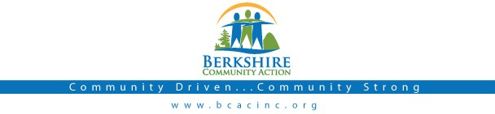

Board Meeting
Thursday
August 3rd, 2017: 6:00 pm

BCAC Community Room

Call to Order (6:00) Roll Call
Agenda: Accept/ Change

Public:

Minutes: Approve minutes from July, 2017 meeting. Vote required.

Board President: Opening remarks

BCAC Program Staff Presentation

Committee Reports:

Finance Committee
  - Resolution to Amend Retirement Plan (Walter O.) - Vote Required
- Audit Committee
  - Audit Reporting Policy/Process (Walter O.) - Vote Required

Governance Committee
  - Governing Board Bylaw Change (Article 4) - Vote Required
  - Attorney Review of Personnel Policies - Vote Required
  - Clarification of Governing Board Role in Exec. Director Evaluation - Vote Required
- Fundraising Committee
- Governing Board Roles and Responsibilities
- Fundraising Gala Discussion

Executive Director Report
  - Up d ate from Deb Leonczyk, Executive Director.
  - Employee Policy Change Notification Procedure - Vote Required
  - Volunteer Documentation Procedure - Vote Required
  - New Employee Orientation Policy- Vote Required

Important Dates:
- August 11 - BCAC Open House
- September 26 – BCAC Fundraising Gala

Adjournment

