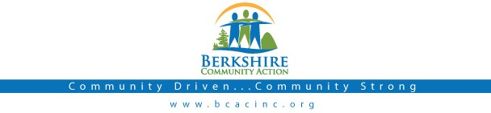

Board Meeting
Thursday
July 6, 2017: 6:00 pm

BCAC Community Room

Call to Order (6:00) Roll Call
Agenda: Accept/ Change

Public:

Minutes: Approve minutes from June, 2017 meeting. Vote required.

Board President: Opening remarks

BCAC Program Staff Presentation

Committee Reports:

Finance Committee

- Audit Committee

Governance Committee

Executive Director Report
  - Up d ate from Deb Leonczyk, Executive Director.
  - Report of 3 year-strategic planning process

Important Dates:
- July 10 – 3-Year Strategic Plan Due to DHCD
- July 12 – LIHEAP Public Hearing - Holyoke
- July 26 – 99 restaurant Fundraiser
- August 11 - BCAC Open House

Adjournment

