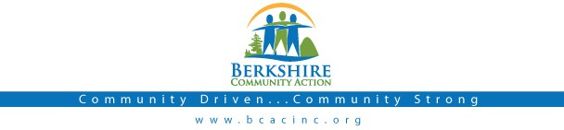

Board Meeting
Thursday
September 7, 2017: 6:00 pm

BCAC Community Room

Call to Order (6:00) Roll Call
Agenda: Accept/ Change

Public:

Minutes: Approve minutes from August, 2017 meeting. Vote required.

Board President: Opening remarks

BCAC Program Staff Presentation

- Community Connector Program

Committee Reports:

Finance Committee

- Audit Committee

Governance Committee

- Fundraising Committee
- Fundraising Gala Discussion

Executive Director Report
  - Up d ate from Deb Leonczyk, Executive Director

Important Dates:

- September 26 – BCAC Fundraising Gala

Adjournment

