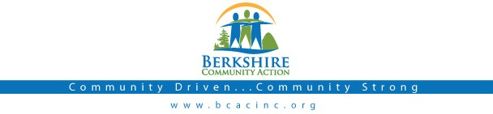

Board Meeting
Thursday Feb 2, 2017: 6:00 pm

BCAC Community Room

Call to Order (6:00) Roll Call
Agenda: Accept/ Change

Public:

Minutes: Approve minutes from January 5, 2017 meeting. Vote required.

Board President: Opening remarks

BCAC Program Staff Presentation: Full agenda, will postpone until March Meeting

Committee Reports:

Finance Committee
  - Report on Fisc al Results for 12/31/2016 Vote required
  - Report on Fiscal Year 2016 Audit Vote required
  - Report on Form 990 for 2016 Vote required
  - Audit Services Checklist Vote required
- Executive Committee
  - New Board Manual Vote required
  - Revised By-Laws Vote required
  - Sign off (all members)
- Risk Management Committee
  - Report on Meeting (minutes attached)

Governance Committee
  - Board membership update, Michael Taylor

Executive Director Report
  - Up d ate from Deb Leonczyk, Executive Director.

Other Business

- New Personnel Policies
  - Client Code of Conduct Vote required
  - Staff Code of Conduct Vote required
  - Building Security Policy Vote required
  - New Conflict of Interest forms (sign off all members)

Adjournment

