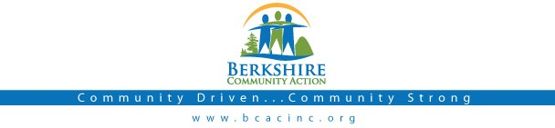

Board Meeting
Thursday January 7, 2017: 6:00 pm

BCAC Community Room

Call to Order (6:00) Roll Call
Agenda: Accept/ Change

Public:

Minutes: Approve minutes from November 3rd meeting. Vote required.

Board President: Opening remarks

BCAC Program Staff Presentation: Tammy Biagini to present LIHEAP Program

Committee Reports:

Finance Committee
  - Report on Fisc al Results for 11/30/2016 Vote required
  - Financial report attached

Governance Committee
  - Board membership update, John-Arthur Miller

Executive Director Report
  - Up d ate from Deb Leonczyk, Executive Director.

Other Business

- Board Activity-Michael Bedford
  - Discussion with the goal of defining the outline of a Risk Management Plan
  - Establishment of a Risk Management Committee

Adjournment

